**1**

**a)** The Earth provides us with many resources. Some of these are shown in the table below. Put a tick to indicate if the resource is finite. (2)

|  |  |
| --- | --- |
| **Resource** | **Finite?** |
| Water |  |
| Metals |  |
| Coal |  |
| Wind |  |

**b)** Oil is another natural resource. Why is oil described as ‘non-renewable’? (2)

Glass is not a natural resource. It is made from sand and other materials. Bottles can be made from glass or plastic.

**c)** Why is it a good idea to recycle glass? (2)

Plastics are much lower density than glass and have many uses. Their properties can be altered by their method of production. Below are two examples of polymers that have been manufactured differently.

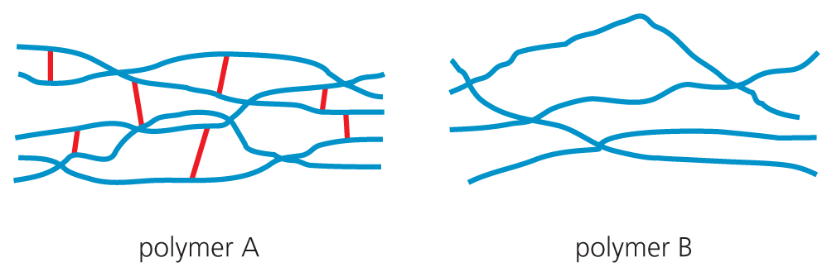

**d)** Explain the difference between these two polymers and how this affects their use. (3)

**2**

**a)** Water can be made fit to drink (potable) in various ways. In Britain, most of the water comes from collected rain water. Some countries do not have enough rainfall. Give two ways in which they can treat water to make it portable. (2)

**b)** What is the difference between pure water and portable water? (2)

**c)** The final stage in purification is usually chlorination. This uses the gas chlorine. What does this process do to the water? (1)

**d)** Why does the amount of chlorine added have to be carefully controlled? (1)

**e)** Why is it important to treat waste water before it is put back into the environment? (1)

**3** Below are two diagrams showing a pure metal and an alloy.



**a)** What is an alloy? (1)

**b)** What advantage does an alloy have over the pure metal? (2)

**c)** Below are some alloys and a list of uses. Match the alloy with its use.

|  |  |  |
| --- | --- | --- |
| **Alloy** |  | **Use** |
| A Bronze |  | Aeroplanes |
| B Gold alloys |  | Coins |
| C Steel |  | Jewellery |
| D Aluminium-magnesium alloys |  | Car production |

A = _________________ (1)

B= _________________ (1)

C = _________________ (1)

D = _________________ (1)

**d)** One problem of using many alloys is that they corrode.

**i)** What is corrosion? (1)

The three test tubes show an experiment to see which metals could be used for the sacrificial protection of the iron nail. Each tube has an iron nail and a metal wrapped round it.



**ii)** How does sacrificial protection work? (2)

**iii)** In which tube will the nail rust the most? Explain why this is so. (2)

Most composites are made of two materials, a matrix or binder surrounding and binding together fibres or fragments of the other material, which is called the reinforcement.

**e)** Give one example of a composite material with its use. (2)

**4** The Earth’s resources are limited and it is getting harder to extract such metals as copper economically. Phytomining and bioleaching are two processes now being used to extract copper from low grade ores.

**a)** What is an ore? (2)

**b)** Pick one of the two processes of extracting copper above and explain how it is used for extracting copper. (3)

**5** The Haber process is used to make ammonia from hydrogen and nitrogen in a reversible reaction.

**a)** What does *a reversible reaction* mean? (1)

**b)** What raw material is used to produce hydrogen? (1)

**c)** What raw material is used to produce nitrogen? (1)

**d)** Write a word equation for the Haber process. (1)

**e)** Write a balanced symbol equation for the production of ammonia. (3)

**f)** Ammonia is used to make fertilisers. In particular, NPK fertilisers. The ‘N’ stands for nitrogen. What do the other two letters stand for? (2)

**g)** The forward reaction in this process is exothermic. The conditions used to produce ammonia are:

Temperature: 450°C

Pressure: 200 atmospheres

Catalyst: iron

Explain why these are seen as ‘compromise conditions’. (6)

Total = 50

**a)**

|  |  |
| --- | --- |
| **Resource** | **Finite?** |
| Water |  |
| Metals | 🗸 |
| Coal | 🗸 |
| Wind |  |

(2)

b) Oil takes **millions of years/very long time** to **form**. (2)

**c)** Recycling glass saves money and resources. (2)

**d)** Polymer A: thermoset; cross-linked; do not soften when heated, hard; used in resins.

Polymer B: thermoplastic; softer; used in packaging. (3)

**2**

**a)** Distillation and reverse osmosis (2)

**b)** Pure water only contains H2O. Portable water contains dissolved salts. (2)

**c)** Chlorination kills bacteria/bugs making the water safe to drink. (1)

**d)** Chlorine is poisonous/dangerous, harmful to humans. (1)

**e)** May contain harmful/poisonous/dangerous chemicals. (1)

**3**

**a)** An alloy is a **mixture** of two or more metals (or carbon + a metal). (1)

**b)** The alloy has **improved properties** e.g. strength, compared with the **original metals**. (2)

**c)** A = coins; B = jewellery; C = car production; D = aeroplanes (4)

**d)**

**i)** Corrosion is reaction of metals with substances in the environment/reaction with air and/or water. (1)

**ii)** Sacrificial protection has a **more reactive metal** attached to the metal being protected. **More reactive metal corrodes first**. (2)

**iii)** **Tube P** because copper **lowest** in reactivity. (2)

**e)** Composite material could be: fibreglass – storage tanks, etc.; concrete – building material; carbon fibres – sports equipment. (2)

**4**

**a)** An ore is a **rock containing a metal** and it is **economically worth** extracting the metal from it. (2)

**b) Phytomining** uses **plants** to **absorb metal** compounds. The plants are harvested and then **burned** to produce ash that contains metal compounds.

**Bioleaching** uses **bacteria** to produce leachate **solutions** that **contain metal** compounds. (3)

**5**

**a)** A reaction that can go backwards and forwards. (1)

**b)** Methane (1)

**c)** Air (1)

**d)** hydrogen + nitrogen ⇌ ammonia (1)

**e)** 3H2 + N2 ⇌ 2NH3 (LHS = 1, RHS = 1, balancing = 1)

**f)** P = phosphorus; K = potassium (2)

**g)**

|  |  |
| --- | --- |
| Marks |  |
| 6–5 | At least three different points well expressed |
| 4–3 | A couple of points mentioned |
| 2–1 | Not much detail |

Compromise because:

* Lower temperature results in a bigger yield because the forward reaction is exothermic.
* BUT too slow OR reverse argument.
* Higher pressure bigger yield because four molecules go to two.
* BUT expensive/dangerous
* Catalyst lowers activation energy so more reacts.

Total = 50